**Clampers**

**Lab # 06**



**Spring 2023**

**CSE-206L Electronic Circuits Lab**

Submitted by:

**Ali Asghar**

Registration No.: **21PWCSE2059**

Class Section: **C**

“On my honor, as student of University of Engineering and Technology, I have neither given nor received unauthorized assistance on this academic work.”

Submitted to:

**Engr. Abdullah Hamid**

**Date**: 7th July 2023

**Department of Computer Systems Engineering**

**University of Engineering and Technology, Peshawar**

**OBJECTIVES OF THE LAB:**

* To become familiar with the function and operation of clampers.

**EQUIPMENT:**

* Oscilloscope
* Function Generator
* Digital Multimeter (DMM)

**COMPONENTS**

* Diode: Silicon (D1N4007)
* Resistors: 10kΩ
* Capacitor: 1 μF

**THEORY:**

**DIODE:**

A diode is a two-terminal electronic component that conducts current primarily in one direction; it has low resistance in one direction, and high resistance in the other.

**CLAMPER:**

A clamper is an electronic circuit that changes the DC level of a signal to the desired level without changing the shape of the applied signal. In other words, the clamper circuit moves the whole signal up or down to set either the positive peak or negative peak of the signal at the desired level.

The dc component is simply added to the input signal or subtracted from the input signal. A clamper circuit adds the positive dc component to the input signal to push it to the positive side. Similarly, a clamper circuit adds the negative dc component to the input signal to push it to the negative side.

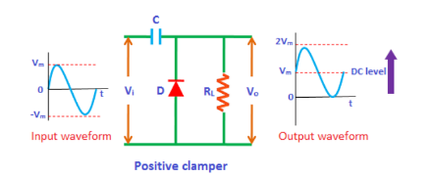

Figure 1, Clamper Circuit

**PROCEDURE:**

**Part A: Clampers (R,C, Diode Combination)**

* Construct the circuit in Fig.1. The input signal is a 10 V p-p square wave at frequency of 1000 Hz. Record the measured resistance value.
* Put probes across source and diode.
* Observe the signal through analogue probing.

**OBSERVATIONS:**

**For Positive Clamper:**

Figure 2a, Proteus Circuit for Positive Clamper

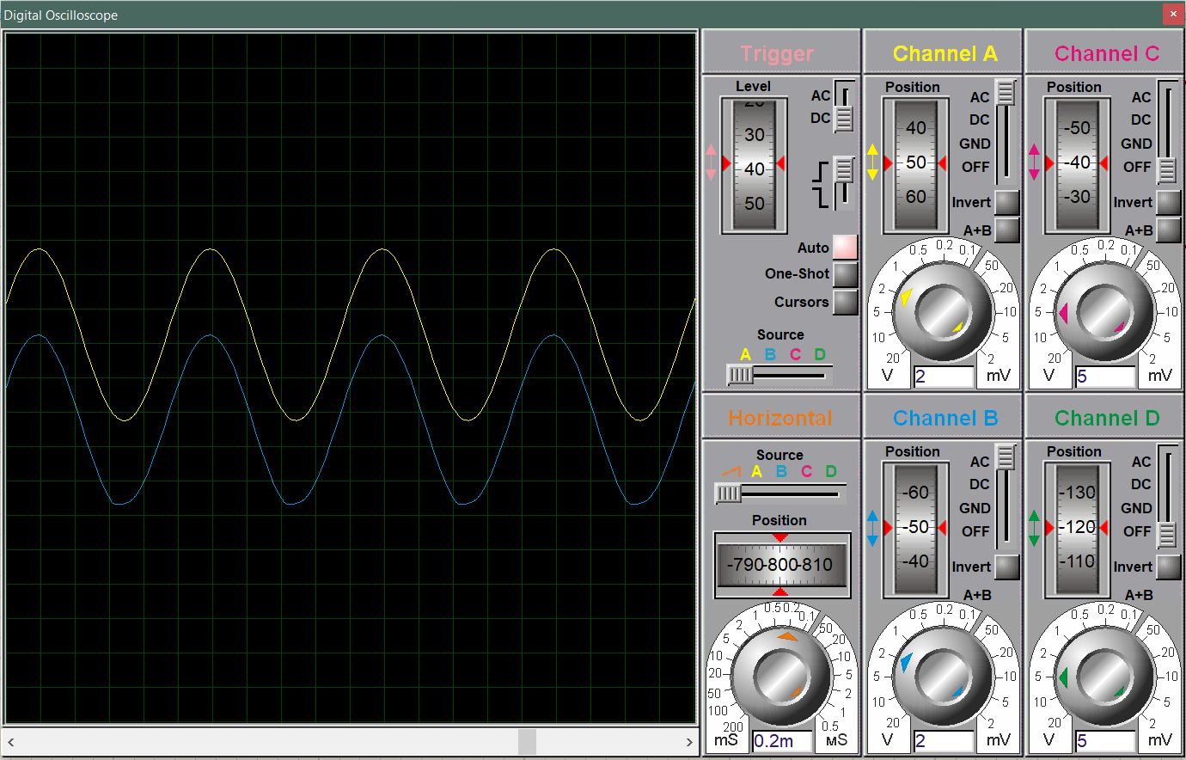

Figure 2b, Oscilloscope output for Positive Clamper

**For Negative Clamper:**

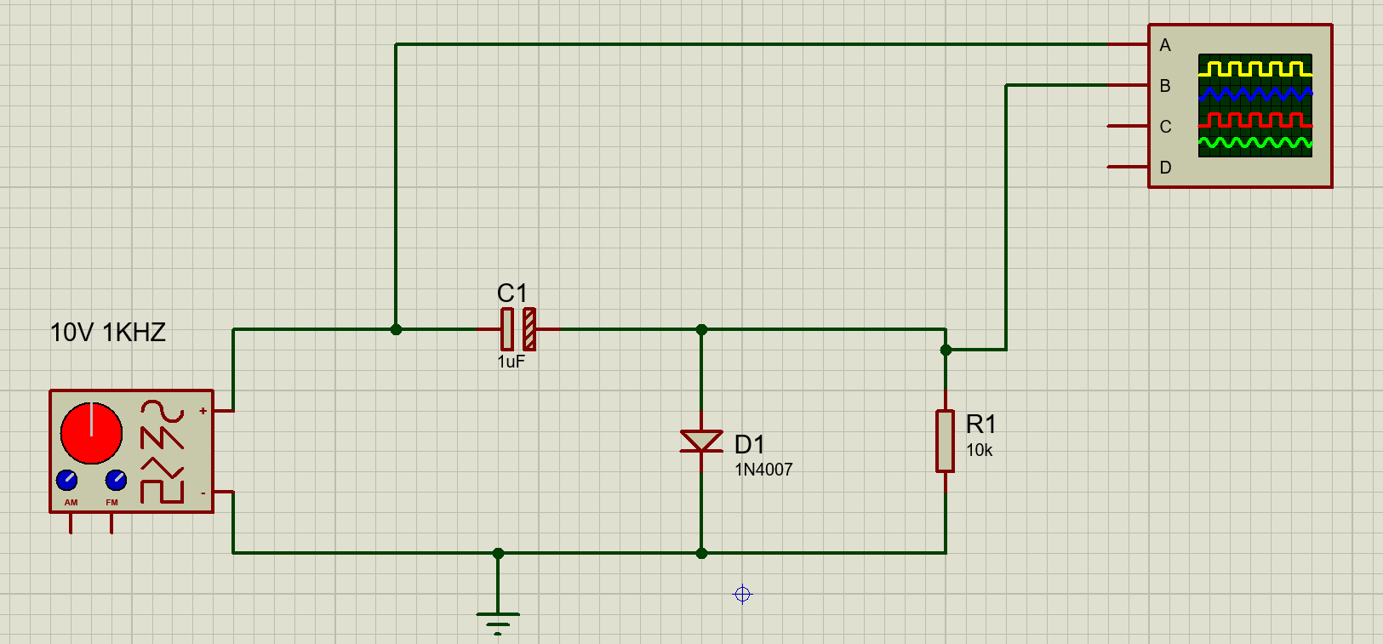

Figure 3a, Proteus Circuit for Negative Clamper

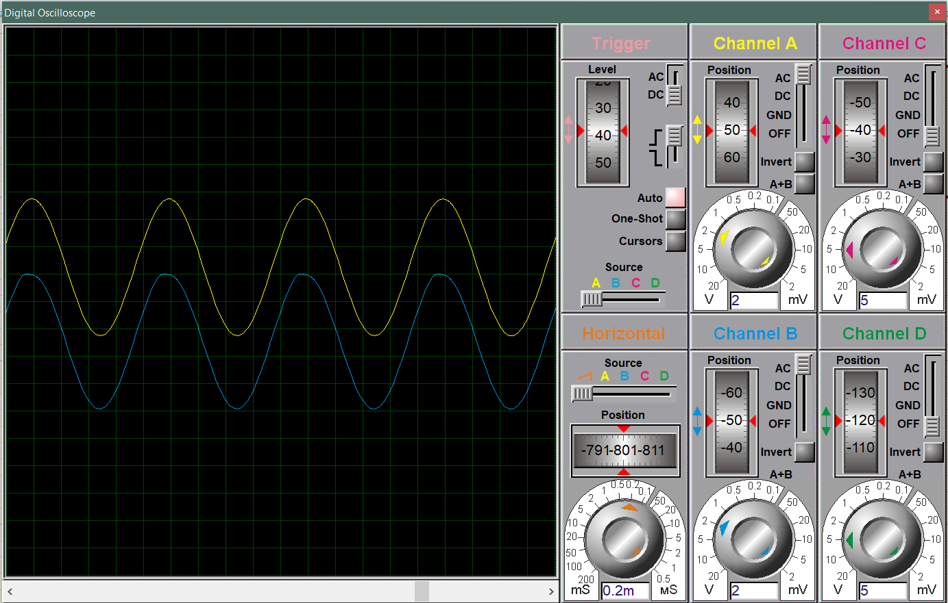

Figure 3b, Oscilloscope output for Negative Clamper

**Part B: Clampers with DC**

* Construct the network by adding a DC source with diode and record the measured values.

Figure 4a, Proteus Circuit for Positive Clamper with DC Biasing

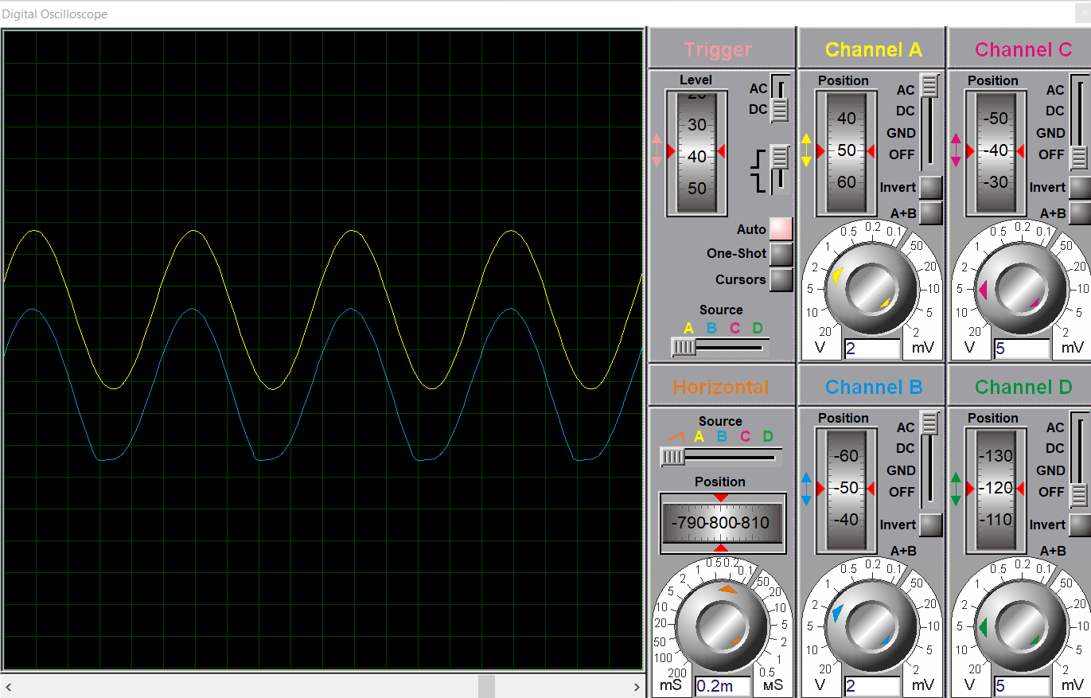

Figure 4b, Oscilloscope output for Positive Clamper with DC Biasing

**PRACTICAL:**

